## Lab assignment # 1 - DDL, DML, constraints and transaction processing

**How do you write the lab report? You can put your answers in this document and provide your code with comments where you think it's necessary. If you can't use this document I would like you to include the task text in your answer. These goes for all lab reports.**

During this lab you will acquire knowledge required to create database objects in the form of tables and sequences. Furthermore, you will see that certain integrity rules mentioned in the tasks is maintained by constraints on the table level.

Do all labs here: <https://livesql.oracle.com>

**Task 1**

Create a sequence object with the name **my_seq**. It should start with 1 and increase by 1. The sequence method NEXTVAL returns a numeric data type.

*----TASK 1: Create the sequence 'my_seq' to generate the value for the next tasks----*

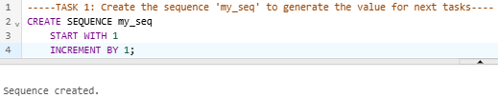

**Task 2**

Create a table structure according to the drawing below:

CUSTOMER

# cust_id

* username

* passwd

* first_name

* last_name

* credit_type

o phone

CUST_ORDER

# ord_id

(#)cust_id

* order_date

CART

# row_id

(#)ord_id

(#)prod_id

* quantity

PRODUCT

# prod_id

(#)group_id

* prod_name

* price

PROD_GROUP

# group_id

* group_name

PROD_PICT

# pict_id

(#)prod_id

* file_type

* width

* height

* path

**Explanation of notation**

# = Primary key

(#) = Foreign key

* = Mandatory (must contain a value => NOT NULL)

o = Optional (must not contain a value can be NULL)

**customer.credit_type** CHECK ('high','average','low')

**prod_pict.file_type** CHECK ('gif','jpg')

**cust_order.ord_id** (generated by the sequence my_seq)

**cart.row_id** (generated by the sequence my_seq)

**cust_order.order_date** (data type = DATE, DEFAULT SYSDATE)

**customer.username** (should be unique, constraint UNIQUE)

**All Foreign Key columns should have the** column constraint **NOT NULL**

Name all constraints except NOT NULL. Suggestion for a constraint naming convention: **table_column_constraint**, you can use the following abbreviations if you like : **CK** = CHECK, **PK** = PRIMARY KEY, **FK** = FOREIGN KEY and finally **UQ** = UNIQUE, or whatever you like as long as you are consistently.

For the customer table above, a primary key constraint would be named:

**customer_cust_id_pk**

*-----TASK 2: Create the tables, constraints----*

*-- Create table CUSTOMER*

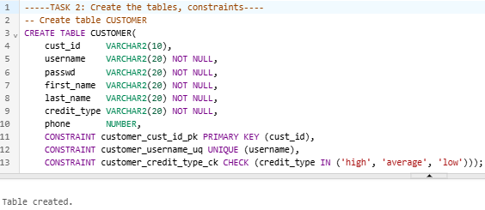

-- Create table CUST_ORDER

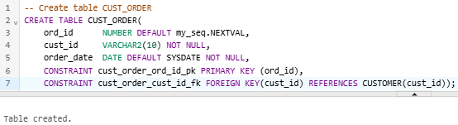

-- Create table PROD_GROUP

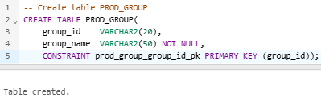

-- Create table PRODUCT

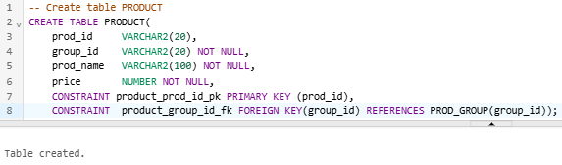

-- Create table PROD_PICT

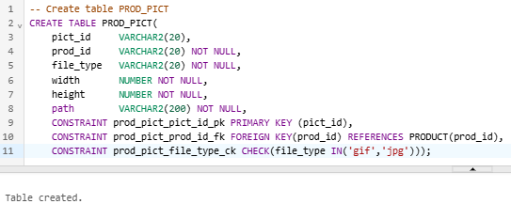

-- Create table CART

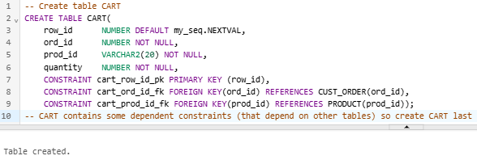

**Task 3**

Insert three rows in the **customer** table.

----TASK 3: Insert data for the table CUSTOMER----

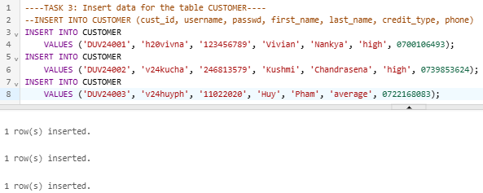

**Task 4**

Insert two rows in the **prod_group** table.

----TASK 4: Insert data for the table PROD_GROUP----

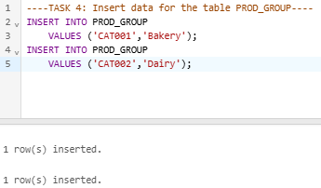

**Task 5**

Insert two rows in the **product** table.

----TASK 5: Insert data for the table PRODUCT----

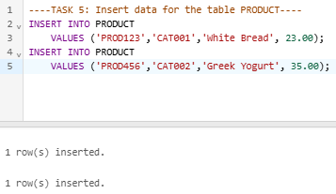

**Task 6**

Perform a sale by creating **one row** in the **cust_order** table and **two rows** in the **cart** table. **Remember** to use the sequence to generate primary key in the tables.

----TASK 6: Insert/Generate data for the table CUST_ORDER----

-- Create the order and match it with the customer's first

-- Create the order and products bought by adding the info into CART

-- Select the highest ord_id to select the most recent transaction before inserting to CART

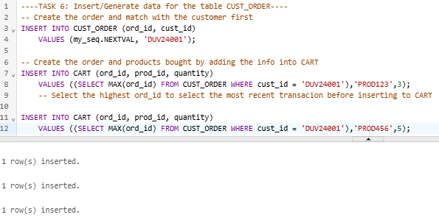

**NOTE** that when you have created the cust_order you must check what value the sequence put in the ord_id column (i.e. the Primary Key value). Then take that number and use it in the insert on the cart table FK-column. **DO NOT USE** the sequence to generate a number to the foreign key ord_id in the cart table!

**Task 7**

Increase the price on all articles by 12%.

----TASK 7: Update the price on all products----

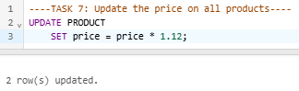

--Check the updated price

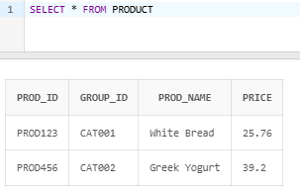

**Task 8**

Update the phone number for an optional customer.

----TASK 8: Update the phone number----

--Change the phone no of user DUV24003 from '0722168083' to '0722168038'

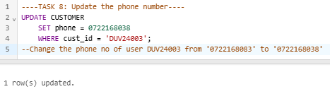

**Task 9**

Delete all rows from the cust_order table, by using DML. **What happens and why!**

----TASK 9: Delete all rows from the CUST_ORDER----

-- It fails due to FK from the CART table refers to ord_id (PK) in CUST_ORDER

-- In this case, we must delete all data in CART, or delete the constraint FK

-- before deleting the rows in CUST_ORDER

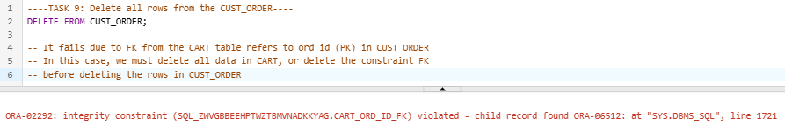

**Submit the lab report in the course room.**

Pär Douhan: [pdo@du.se](mailto:pdo@du.se)